CSCI 5408 DATA MANAGEMENT AND WAREHOUSING
ASSIGNMENT – 2

SUBMITTED TO: PROF. SAURABH DEY

SUBMITTED BY:
DHRUV DOSHI
B00883311

GITLAB LINK:
https://git.cs.dal.ca/doshi/csci-5408-s2021-b00883311-dhruv-doshi/-/tree/master/A2

PROBLEM 2 TASK 2

There are two files named transaction_initial.java and transaction_after.java in which the driver code is stored in gitlab.

The code is written in the manner through which everything is saved in the log file named in the code.

I had two option to move further
- Stack
- Queue

I choose the Queue option because for the sequencing task I thought queie would be the better suitable option.
For development of queue I am using Linkedlist as it is best possible data structure to work with queues.

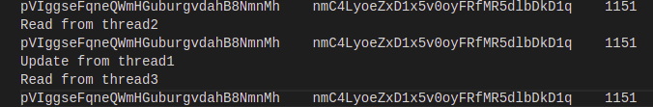

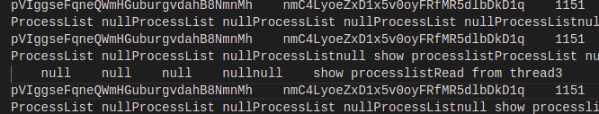

Here in images the output is being demonstrated that how the code is working on my pc. Here as we can see for the initial image everything is working but for the next image there as issues with null walues because of the locking.

